There is an n x n **0-indexed** grid with some artifacts buried in it. You are given the integer n and a **0-indexed**2D integer array artifacts describing the positions of the rectangular artifacts where artifacts[i] = [r1i, c1i, r2i, c2i] denotes that the ith artifact is buried in the subgrid where:

* (r1i, c1i) is the coordinate of the **top-left** cell of the ith artifact and
* (r2i, c2i) is the coordinate of the **bottom-right** cell of the ith artifact.

You will excavate some cells of the grid and remove all the mud from them. If the cell has a part of an artifact buried underneath, it will be uncovered. If all the parts of an artifact are uncovered, you can extract it.

Given a **0-indexed** 2D integer array dig where dig[i] = [ri, ci] indicates that you will excavate the cell (ri, ci), return *the number of artifacts that you can extract*.

The test cases are generated such that:

* No two artifacts overlap.
* Each artifact only covers at most 4 cells.
* The entries of dig are unique.

**Example 1:**

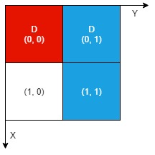

**Input:** n = 2, artifacts = [[0,0,0,0],[0,1,1,1]], dig = [[0,0],[0,1]]

**Output:** 1

**Explanation:**

The different colors represent different artifacts. Excavated cells are labeled with a 'D' in the grid.

There is 1 artifact that can be extracted, namely the red artifact.

The blue artifact has one part in cell (1,1) which remains uncovered, so we cannot extract it.

Thus, we return 1.

**Example 2:**

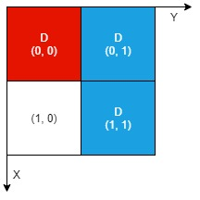

**Input:** n = 2, artifacts = [[0,0,0,0],[0,1,1,1]], dig = [[0,0],[0,1],[1,1]]

**Output:** 2

**Explanation:** Both the red and blue artifacts have all parts uncovered (labeled with a 'D') and can be extracted, so we return 2.

**Constraints:**

* 1 <= n <= 1000
* 1 <= artifacts.length, dig.length <= min(n2, 105)
* artifacts[i].length == 4
* dig[i].length == 2
* 0 <= r1i, c1i, r2i, c2i, ri, ci <= n - 1
* r1i <= r2i
* c1i <= c2i
* No two artifacts will overlap.
* The number of cells covered by an artifact is **at most** 4.
* The entries of dig are unique.